**RCCI Year-End Report and Self-Assessment for AY 2015-2016**

**June 14, 2016**

**Executive Committee: Mark Ballora, Scott Bennett (co-chair), Adam Caimi (ex-officio), Tom Canich (Advisory Council co-chair), Doug Cowen, Matt Decker (ex-officio), Michele Diaz, John Domico (ex-officio), Jenni Evans (ex-officio), Eric Ford (Advisory Council co-chair), Dan Haworth (co-chair), Rob Hume (co-chair), Greg Madden (ex-officio)**

This report summarizes the accomplishments of the **Research Computing and CyberInfrastructure (RCCI)** governance structure during the 2015-2016 academic year, along with an assessment of challenges and opportunities facing RCCI in the near future. Appendix A includes a summary of key accomplishments and ongoing projects on specific fronts from the point of view of the “research guru” office. Appendix B includes the annual reports of each of the RCCI working groups. Overall, RCCI is accomplishing its goal of creating a communication network between faculty researchers, university administrative offices, and IT units that have a major influence on research computing. It has created working groups that are addressing issues both narrow and broad, in the sense that some issues are specific to high-powered research (e.g. HPC systems) while others reach beyond research computing to include data governance, computing networks, compliance, software purchasing, the data center, data categorization, and IT issues in HR. Many projects are ongoing, and we have seen a desire for cooperation in relevant administrative offices, IT units, and with faculty stakeholders that is allowing us to gain traction on thorny cyberinfrastructure issues. Without the presence of RCCI, it is doubtful that many of these critical topics would be being tackled at all, let alone with broad input from the research community and other critical stakeholders.

*Organization and Activity*

The inaugural meeting of the **RCCI Advisory Council was held on May 13, 2015. This followed** approval for the creation of the RCCI governance structure in December 2014, and initial solicitations for Council members from Deans and Institute Directors. **Early organizational activities included agreeing to an initial set of working groups, populating those working groups, and selecting working group chairs (June 2015).** Members of the Advisory Council (AC) nominated representatives for the RCCI Executive Committee (EC) during the summer of 2015; the EC was formally **announced on September 11, 2015. Shortly thereafter, Greg Madden was hired as the** Senior Advisor for Research Computing and Cyberinfrastructure (informally known as the Research Computing “guru”). During fall 2015, **most of the RCCI working groups focused their meetings on understanding the current research computing environment and identifying priorities to be addressed by their working group (as detailed in the earlier December 2015 RCCI update). During spring 2016, each of the working groups met several times (typically monthly, but some biweekly) and made significant progress on these issues (see working group progress reports in Appendix C). The High-Performance Computing working group also acted promptly to respond to multiple urgent matters.**

*Membership*

**We have encouraged working groups to meet as appropriate during the coming summer and then to resume their regular meeting schedule in August 2016. After thanking all RCCI AC members for their service, units were asked to name the faculty and IT professionals who will serve as their RCCI AC representatives during the coming year (with terms of new members officially starting August 15, 2016). While most units have responded, we are still following up on obtaining representatives from other units. A membership committee is now in place to help onboard new RCCI AC members and to respond to changes that arise during the year.**

*Research Computing Guru:*

Senior Advisor for Research Computing and Cyberinfrastructure Greg Madden (informally, the RCCI “research guru”) has been cataloging both existing services offered and challenges for research computing at Penn State. The guru has helped bring together key people and offices to overcome problems, such as helping Health and Human Development researchers meet their compliance and data transfer needs via a combination of ICS-based storage and improved use of networking protocols. The guru office has served as an ombudsman where faculty and unit issues in research computing have been brought. Having identified over 130 serious issues, there is clearly more to attend to than is possible for one person. We need to move toward seeing the research guru as an office that facilitates research computing and cyberinfrastructure relevant for research, and not just a single person. The RCCI AC/EC recommends hiring multiple “associate gurus” who will serve as high-level consultants to help solve complex research computing challenges, particularly those that require the coordination of multiple units and offices. We believe that we should take opportunities to obtain assistance as soon as possible, even as the precise shape of the office evolves over the next few years.

**Successes**

1. One major task of the RCCI is to create a communication network between faculty researchers, university administrative offices, and IT units that have a major influence on research computing. Sometimes these influences are broad in scope (at the university level) while at other times they are small (within departments). In practice, this network is being “constructed” by the research guru and working groups who bring in others outside of the initial participants. We have clearly brought together people who needed to talk to one another. In some cases there was not a forum for the relevant individuals to communicate, or stakeholders did not know how to reach other stakeholders; in other instances, groups discussing particular issues across campus did not know that other groups existed with a similar focus/interest. We have been successful in bringing together faculty and IT personnel to discuss important issues, and have received many positive internal comments about this engagement (including faculty/IT co-chair arrangements).
2. In some cases there has been clear resolution of issues (e.g., rectifying issues of connectivity between HHD and ICS-ACI, pushing software asset management tools out). In other matters, there has been engagement that has not yet reached resolution (e.g., Data Center) or the collection of information that is the basis for additional/future discussion (e.g., administrative rights policies).
3. We have had the greatest success in areas where there exists a specific service that we are attempting to influence positively. This includes areas such as in HPC (via ICS-ACI), the Research Network, the Data Center, Software Asset Management, and Data Archiving (as represented by Data Commons, Scholarsphere, and Databrary).  We have learned that in many of these instances, (1) the services want to satisfy their users but have had insufficient contact with their users (especially researchers) to understand user needs and workflows, and (2) many related services have worked in a vacuum, with ill-defined interfaces to other related (and sometimes parallel) services. In meetings coordinated by the guru and within our working groups, we have facilitated contact between services and users, and between faculty, administrators, and IT professionals. We have had excellent results in facilitating conversations between a wide variety of stakeholders that are leading to improved shared processes. This is true of data acquisition processes, software acquisition processes, data use agreements, data compliance, and ACI's interface to the Research Network. In each case, the individual services deserve full credit for working with other teams to create improvements, but RCCI has served as a match-making mechanism to assemble relevant people in the same room with a common mandate to improve computing and the computing environment for researchers.
4. Our progress has been less obvious in those areas where there is no specific service to influence (for example, in tackling data governance issues), and in areas which are overwhelmingly large (for example, in IT/HR issues and again, data governance). In those areas there has been movement and a remarkable degree of communication between individuals and offices that had not been working together, but not yet resolution. In regards to data governance, we have brought at least 11 separate groups (OSP, ORP, RCCI, ITS, Procurement, Risk Management, IT Audit, OIS, OGC, IRB, IT Software Services) together. These groups are now working towards improved processes around data and an efficient onboarding process for faculty. The data governance working group will be convening a data categorization summit this summer to discuss the development of a data categorization scheme among all relevant parties that will be both useful and effective, not just for classifying research data, but for considering broader issues of compliance and security. On the compliance front, we are engaged with many of the same groups to improve the response time for data onboarding and to prepare the university for the upcoming onset of NIST 800-171 requirements. On the IT/HR side, we have surveyed IT staff and have put specific recommendations before the Provost. We have laid an important foundation in all of these areas, but it will take some time to reach resolution.
5. Members of RCCI are involved in the CISO advisory committee, and are contributing to searches for important leadership positions, such as the VP for IT, Chief Information Security Officer (CISO), and ICS Director. This involvement is important for ensuring that Penn State recruits leaders who understand the unique needs of research computing within the context of a complex research university.
6. Working in conjunction with the AC and AC working groups, the RCCI EC has made recommendations on issues including IT security, IT/HR, HPC, data categorization, data archiving, and the structure of a revamped IT organization. We take it as a vote of confidence that we have been solicited by members of the administration to provide input on a variety of computing-related issues.
7. We have established both mailing and membership lists, and created a membership committee to deal with the 50-person AC.

**Challenges and Opportunities**

1. The “guru” operation has been particularly successful in creating links between RCCI, local IT groups, administrative offices, and the EC. The guru has also served as a key person with the knowledge to connect working groups to key administrators, and served as an ombudsman to mediate issues between central offices and local departments and individuals. The long list of impending tasks for the guru has been circulated to EC for information, with many matters and discussions ongoing. However, while connections and significant progress have been made, and discussions have been facilitated, the guru’s workload has been much more than one person can reasonably accomplish. The guru shop is understaffed for the number of issues that have been brought to it and meetings that demand the guru’s attention. This has led to a delay in the publication of a research cyberinfrastructure service catalog (currently in progress), other public output such as onboarding materials for research faculty, and regular meetings between the guru and all units across campus. We have also been unable to advertise the guru’s services widely as an individual contact for faculty researchers, but the guru has also not had time to work extensively to promote culture change and faculty research contact within local IT units. While occupied fully with urgent and immediate priorities, the guru thus far has been unable to consider the “big picture” concerning research and the research computing technologies needed at PSU at the broadest level. The ombudsman role of the guru in solving immediate crises, and linking individuals who are working on subjects germane to one another, have been essential. However, we need to expand this office in order to address the 100+ items on the Issues list that 1) require input from the research computing community, or 2) require coordination of actors from multiple groups that are often not in communication (e.g. ITS, units, administrative policy-making offices), or 3) require time for preparation of publicly-accessible documents.
2. We are a large body, and we have several working groups. Some teams have expressed difficulty in knowing whether their group is working on a task that overlaps with another group’s work. Related to this, one group discovered that a different team was talking to exactly the same offices about an issue related to their own, and worried that this demonstrated a lack of coordination to our outside contacts. Groups have also voiced concern in regards to internal discussions that may be superseded by things going on elsewhere (e.g., in administrative offices or with the apparent ongoing development of central policy). Although the guru and some co-chairs are already spending significant time on this, it seems that there could still be more coordination between groups. We recommend that the Advisory Council continue to work on improving communications within the advisory council's many working parties. We will continue to use the chairs’ meetings to facilitate coordination, and discuss other options for coordination.
3. We would like to find better ways to communicate between the advisory council and the broader Penn State community. For external-facing communications to public constituents, Penn State Today is arguably effective. For internal-facing communications to faculty-and-staff constituents, however, we do not have any platform by which we can easily reach researchers, research administrators, other administrators, and IT professionals, such that all of those groups can be apprised of information that might affect how they deal with one another. Penn State has many tools (Yammer, various Listservs, ITS Newsletter, departmental and College mailing lists, and of course general email) but many are not used consistently by the many groups we engage with. We will consider creating a Communication Working Group to address the problem of internal communications.
   1. For this group, we could invite relevant stakeholders representing the known communications platforms in use on campus, to include the Office of Strategic Communications, ITS Communications, ACI Communications, Yammer representatives, Listserv representatives, and so on. The group could help both for RCCI in terms of facilitating our communications, but we could also make recommendations about the broader issue of campus communication.
   2. We could also use the communications working group to assist in the development and dissemination of researcher onboarding materials, the research computing service catalog, and other formal RCCI materials that need to reach the user community.
4. After this initial academic year, we need to revisit the scope and charge of the different groups. Should some be merged? Repurposed? Are there similar issues being tackled in multiple groups where we should re-organize tasks and personnel? We need to think about the overall set of groups, to clarify the authority and scope of some working groups, and ensure clear goals and objectives of work. We should also think about when and how to disperse a working group once it has completed their assignments successfully and the group is no longer needed. If issues are settled, then we don’t need to continue to look for new issues and tasks.
   1. Example 1: Questions came up in the Research Network working group about whether it was within their scope to create policies about who should have access to the research network, or to create a cost structure for using the research network (since some of the cost are standard TNS fees, but not everything is).
   2. Example 2: Does data categorization belongs with the “Research Network and Data Categorization” group, or is it better located elsewhere? It was placed initially because part of the point of the research network was to allow particular forms of protected data to be transferred securely and compliantly. But while the types of data that can flow across the research network are important to know, the actual process of determining the data categories seems a better fit for the Data Governance workgroup (or perhaps the policies workgroup, or a compliance group if one should be developed). For the moment, the distinction in place is that defining the data categories will belong to a subgroup of Data Governance, while responding to those data categories with appropriate protections will belong to the Research Network.
   3. An internal response on the issue of scope in groups is that each group should feel free to tackle issues of any scope they deem useful to improving the computing situation they are considering. All actions of all working groups, the AC, and the EC, are in the form of recommendations to appropriate people. If a group feels that a cost or policy should be something in particular, then the group’s course of action should be to write up whatever policy or cost structure recommendation it believes is needed. Alternatively, a working group can write down multiple sides of an issue or multiple options, and we can have a “hearing”’ with the right folks for discussion and resolution. The EC and AC can endorse or offer alternative recommendations, and forward it to those who can implement policy. We want groups to go as big or bold as they believe they need to. We should continue conveying this message to working group chairs.
5. We need to encourage more activity by more people; in particular, we need more and more active faculty involvement in some areas.
   1. We need to ensure a strong and persistent researcher voice on all issues, including data categorization and risk assessment. We have reached out to some Deans to subtly distinguish between particular personnel who have made major contributions, or been less active. We may need to be somewhat stronger in this area.
   2. We also tend to put a lot on the people that are engaged and very little on others. How can we get others more deeply involved, so that we don’t have to put so much on a small number of individuals?
6. We need to improve how we approach membership, and improve our ability to deal with membership change and member responsibilities/engagement. For example, we have had delays in processing membership requests, in generating responsiveness from our represented units (e.g. from College Deans) in providing new members, and in keeping all members of the AC engaged. To address these needs, we established a membership committee in spring 2016 to handle requests to Deans for new (and replacement) members, to keep working group membership lists up to date, and to address membership issues as they arise. We now have flowcharted processes in place, and hope to use and then refine those processes for the upcoming 2016-2017 academic year (most of our current requests were received before processes were finalized, and hopefully future requests will be handled efficiently). An improvement to consider is to recruit faculty to participate on the membership committee. To date, the committee has been fully appointed with staff, who may be uncomfortable when determining the merit of a faculty candidate for AC membership.
7. Faculty chairs have expressed that there has been more work involved in their position than they expected, and that it took substantial chair action to make significant accomplishments. IT staff representatives also expressed that they have been putting a lot of time into this effort. In some cases, particularly for staff who do not prepare an annual activity summary or are in situations where their supervisor does not value committee membership and activity, this has been largely without compensation. We need to be sure that we share the accomplishments and contributions of AC and EC members with their supervisors at all levels, up to and including Deans, so that individual effort in service of this initiative is recognized. In the long run, we hope that our efforts will effectuate culture change so that big picture, team, committee, and research support is valued universally. Co-chairs are highly recommended. We also need to consider appropriate forms of compensation for both faculty and IT chairs.
8. Dedicated and consistent staff support would be helpful. There are many meetings, and chairs have had difficulty in facilitating meetings with their group members. We have benefited from support provided by ICS and the office of the VPR, but have also had some turnover which has limited our ability to effectively use this support; we hope our use of available support will become routinized and this will be better in the future.
9. We need to continue discussion on how to best incorporate administrative offices and personnel. In discussion, the question arose whether the RCCI should be working jointly with administrative offices to problem-solve and prevent problems from arising, or whether the RCCI should be more clearly “governance” with more of a directive approach.
   1. One perspective was that this was a false dichotomy, and that we should work cooperatively whenever possible while clearly stating faculty requirements when necessary, or when joint activity does not lead to outcomes that help researchers.
   2. A specific suggestion for future discussion is that administrators from various offices should be made formal members of the AC (currently, working groups pull in administrators and administrative offices as needed, but they are not formal AC members). A point against this suggestion notes that administrators are not the stakeholders the RCCI is designed to represent. RCCI represents shared governance, and is built with researchers and the research enterprise acting as the key stakeholders. Although clearly the goal of building a good working network of relationships is necessary to achieve this. The AC is designed to consist of faculty and IT professionals, and although administrators should be pulled in as necessary, RCCI must remain independent.
10. It was suggested that it might be helpful to have more clarification on the specific roles of the EC and the full AC, and procedures for developing and forwarded recommendations.  Point 4c above (that working groups should tackle issues of whatever scope they deem necessary and forward their recommendations to the EC and/or full AC) should clearly be reiterated with working group chairs. In one case in 2015 (the HPC working group), an AC working group forwarded a report which was supported by the EC and forwarded on. On other issues, the EC has drafted various responses to issues and recommendations, and these have been circulated to the AC. Is there clarification needed on roles and procedures?
    1. A specific point to add to the RCCI policies and procedures document is that any recommendation from a working group will be transmitted verbatim to wherever the recommendation is going, possibly with EC endorsement or modification.
    2. Another policy handbook update is to add the membership committee and membership procedures.

**Appendix A: Guru Report / Summary of Progress on Key Issues**

1. DATA CENTER

There have been ongoing discussions with Data Center personnel, but there are few concrete answers to many of our initial Data Center questions. This may be at least partially related to the uncertainty in changing IT leadership. With concerns raised about balancing needs for physical security and access, planning and capacity, much of the Data Centers project was put on hold with the exception of plans for moving ICS-ACI and Hershey into the Tower Road facility. The project charter, relevant stakeholders, and networking and equipment SLAs haven't yet been approved, and there remain concerns about how quickly an additional expansion of power capacity in the Tower Road facility might be needed. There is no clear sense of what services will be provided by the Data Centers, how much those services will cost, how the costs will be administered, whether or not the same set of services will be provided in all the Data Centers, or alternatively whether or not each Data Center will have unique capabilities to meet different needs. The RCCI Data Center Working Group conducted a survey to understand needs and potential barriers to migrating to the data centers, and ICS-ACI and the guru are in regular contact with Data Center personnel. Data Center management has expressed appreciation for our ongoing interest and advice.

1. HPC

Since most HPC on campus is provided by the ICS-ACI, most of the work surrounding HPC is understandably related to ICS-ACI.

* The HPC working group made recommendations (endorsed by the EC) about ICS-ACI rates in fall, 2015. A response was delayed until the end of the 2015-2016 academic year largely because of uncertainties due to delay in passing a state budget. The response was not fast enough to prevent a group of faculty from going ahead with their own HPC hardware purchase outside of ICS-ACI. In May, 2016, a major reduction in rates was announced by the Provost and ICS Director. We view this reduction as a big win for high-performance computing on campus, and it is likely to attract many new users to the ICS-ACI facility.
* We suggest that ICS-ACI seek to develop a process for updating rates and subsidies, especially as prices drop in the future, so that additional requests for outside cluster purchases are minimized in the future.
* RCCI brought together the ITS AWS (Amazon Web Service) Working Group and the ICS-ACI, but they only met once and the ITS AWS service has gone forward without further input from ICS-ACI. With ICS-ACI a likely key purchaser of AWS services on campus, the lack of coordination is concerning.
* Issues surrounding decommissioning and dispensation of aging ICS-ACI equipment were discussed extensively and some recommendations were drafted. The HPC working group made it clear to ICS that this was an important issue for discussion, received clarification about what ICS’s current plans are, have gotten a verbal commitment for more notice in the future, and have asked the ICS Coordinating Committee to propose a plan for future decommissioning that they can comment on. No final resolution has yet been arrived at. The issue may rise again now that at least two separate groups have expressed an interest in acquiring Cyberstar.
* A “Portfolio of Services” document sent around in late April illuminates ACI's plans for phases 3 and 4, and identifies other possible services of interest for the future. We believe it would be beneficial if ICS-ACI’s future plans were more widely publicized.

1. SUITE OF SERVICES

We now have an Advanced Research Computing Portfolio of Services document, and we have agreement from the Service Management Office and the Research IT Directors to try to cooperate on a Service Catalog. We don't yet know what form the catalog will take, nor has there been a final decision about which specific set of services should be implemented at the University. Initial meetings of the service catalog group are scheduled for May.

1. SOFTWARE

The Software Asset Management project is live. The Software Working Group has created a "Software Acquisition Processes" subgroup that includes representatives from all of the central administrative offices involved in vetting software license agreements; they are working to streamline review processes (e.g. through Purchasing, Risk Management, Security) and make the entire process faster and easier. Getting all of these groups together represents one of our biggest successes in RCCI. The same set of offices were already involved in the Data Use Agreement Working Group, and are now trying to figure out if they can develop a single set of master processes that would streamline both data and software acquisition.

1. STORAGE

Storage rates at ICS-ACI have dropped far enough that we are beginning to pull customers to the ICS-ACI for their research storage needs: HHD and Berks have both onboarded in recent weeks; Liberal Arts assessed the ICS-ACI cost for a large volume of secure storage as lower than what they could purchase and host themselves. ICS-ACI has received approval to move forward with a near-line storage solution which will provide additional options, including options for archiving. We have not yet addressed other key questions surrounding storage at Penn State, including finding a permanent solution to secure storage.

1. DATA GOVERNANCE / ARCHIVING AND STORAGE

ICS-ACI has been in discussions with the Libraries. The Libraries have been in discussions with ScholarSphere, Data Commons, and Databrary. There is a subgroup of Data Governance now devoted to archiving and the data life cycle.

1. DATA GOVERNANCE / SECURITY AND COMPLIANCE

The university "Data Use Agreement Working Group" has shifted to be part of the RCCI Data Governance working group rather than running separately. RCCI has representation on a university working group devoted to creating "Compliance as a Service," and has representation on a group devoted to developing a formal Penn State interpretation of the NIST 800-171 guidelines. There is a huge amount of work going in to security and compliance at this point. We are on target to both streamline the process for researchers, and provide comfort to administrators who have to sign that research is compliant.

1. IT/HR CLASSIFICATION AND COMPENSATION

The IT/HR working group report was sent to the Provost in May, 2016.

1. RESEARCH NETWORK

There has been significant progress on issues surrounding the Research Network, which is reflected in the working group annual report below. De facto research network manager Ken Miller has requested that the RCCI Research Network Working Group serve as his official stakeholder governance organization.

1. FACULTY ONBOARDING AND CONTINUING EDUCATION

Although the RCCI Data Governance Working Group has a subgroup devoted to this, relatively little progress has been made so far.

1. POLICIES AND PROCESSES

We have made progress towards streamlining the data acquisition and software acquisition process, are working on data categorization, and are engaged with university offices on the compliance front. However, we haven't tackled large central policies yet, including on general security (although RCCI personnel are on the CISO advisory board). In part this is because searches for key University IT leaders are ongoing.

1. IT RATES IN GRANTS

Discussions have revealed differences of practice and philosophy about funding IT support from grants, and what level of units (central, or local units) should bear the cost of support and compliance. Differences in position and understanding on this issue extend even to the point where fundamental differences in belief exist about whether IT support and compliance costs may legally (under either PSU or federal rules) be charged to grants. A particular question is whether the costs for IT compliance (e.g., the costs of maintaining data securely, processes for obtaining certification that compliance has been met) should be borne centrally, or by individual researchers and grants. It appears that many University Park researchers and administrators believe compliance costs should be funded centrally, but others (including many IT leaders and Hershey IT leaders) believe the costs should fall to the researchers, or at very least should not be funded by IT. At some point this will need to be adjudicated if Hershey and UP are to be following the same practices on grant submission.

1. MISCELLANEOUS

* Connectivity issues between HHD and ICS-ACI over the university network were resolved after several months of discussions between many parties, testing of hardware and firewall configurations, and testing of various software solutions.
* We worked with Jeff Reel (ITS) and Wayne Mowery (Compliance and Export Control) to generate buy-in from key concerned offices that will allow the university to go forward with Office 365.
* We did not get a post-breach briefing or “lessons learned” forum related to the Engineering and Liberal Arts breaches.
* The university’s 2FA implementation project happened.
* ICS-ACI, RCCI, and other UP personnel/representatives coordinated two summits with Hershey on areas of IT/data/HPC/research informatics coordination, ending up with the identification of common areas of interest and the promise of further cooperation.

**Figure 1: RCCI Network Links**

**../../../../../../Documents/rcci-structure-v**

**Appendix B: Advisory Council Working Group Reports**

**I. RCCI AC High-Performance Computing Working Group Progress Report for 2015/16**

**(Chris Forest and Adri Van Duin, co-chairs)**

**Accomplishments for Fall 2015/Spring 2016**

* Discussed a request from a faculty group for University support of a faculty-owned computer cluster. This resulted in a formal document with recommendations that was passed on through the RCCI Executive Committee to the VPR recommending either a reduction of the ICS-ACI pricing or, if not feasible, VPR support for faculty owned computer clusters. We are optimistic that the recommendations of the HPC WG and EC on this matter will directly lead to a substantial improvement in ICS-ACI pricing for the upcoming academic year.
* Invited ICS-ACI to provide a post-mortem on the LionX outage around Thanksgiving 2015. This resulted in an overview that was presented in the HPG WG and sent to the LionX user base. The HPC WG commended the devotion and technical expertise of ICS staff in the ICS handling of this outage. The HPC WG also offered recommendations for improving communications for any future outages.
* Inventoried HPC strategies in other universities and compared their situation with Penn State.
* Discussed the need for multiple hardware/cost/service models within ICS.  We understand that ICS-ACI is now working to increase the number of service models available to researchers, incorporating inputs from the HPC WG.
* Assisted in the formulation of an HPC survey that will provide data critical to defining what hardware should be purchased as part of the upcoming the ICS-ACI Phase 3 computing environment. This survey was sent to faculty and researchers in April 2016 and received over 300 responses.
* Discussed the fate of decommissioned LionX-machines. This is more complicated that one would think and is an ongoing discussion.
* Formulated guidelines to ICS for the future decommissioning of the remaining LionX-machines and eventually ICS-procured hardware. Recommended operating machines after warranties expire with a reduced level of support (e.g., not replacing defective nodes) and providing users a minimum 6-month warning to the user-based of the to-be-decommissioned machine.
* Discussed Amazon AWS services and relevance for different types of academic research computing.
* Discussed NIST requirements for data handling - ongoing discussion.
* Discussed new Tower Road Data Center and its implications for HPC.
* Discussed connection between the HPC WG and ICS organizational structures.

**Planned Work for Fall 2016/Spring 2017:**

* Assist in interpreting the computing survey and formulating the plans for ICS-ACI Phase III procurement.
* Provide recommendations for current and future service options offered by ICS-ACI, e.g., What should be part of new service level agreements (SLAs)?
* Participate in communications between HPC WG and Data Center WG to project future power needs for research computing needs and thus timing of future phases of Data Center buildout.
* Discuss shutdown schedule of Lion-X and ACI clusters and develop communication plan for users
* Develop relations between our HPC working group and the ICS working groups.

**II. RCCI AC Data Centers Working Group Progress Report for 2015/16**

**(Doug Dodson and Eric Ford, co-chairs)**

**Data Centers Working Group Accomplishments for Fall 2015:**

* Educated the working group members on the status and features of the UP and Hershey Data Centers. The working group completed a tour of the University Park Data Center on Dec. 11.
* Representatives from the working group attended all four sessions of the "Data Centers Networking Community of Practice" group.  We focused on ensuring that the interests of Research Computing (as opposed to enterprise systems) were well represented.  As a result of our participation, several concerns about research computing were noted and discussed in the final meetings of this group.
* Developed a survey that was sent out to units involved in research at the University.  The survey was designed to ascertain what issues would be of concern for researchers and IT groups if Penn State were to strongly encourage them to relocate equipment to one of a few large Data Centers.  We found that the survey was also helpful in improving communications between to the Penn State Data Centers group and the faculty and IT groups they serve.  For example, initial survey responses indicated many people were reluctant to relocate their equipment, often citing a lack of information and/or concerns about physical access.
* Brought in several researchers with specialized needs (e.g., cybersecurity research) who described their work and participated in discussions focused on how they could potentially interact with Penn State Data Centers in the near term and in the future.
* Began development of a workbook to help with future transition planning recommendations.
* Began discussions on assisting the Data Centers Management team with the creation of an SLA that will accommodate a broad spectrum of University customers - including Research.

**Data Centers Working Group Accomplishments for Spring 2016:**

* *Data Centers Governance:* We have been working primarily with Mark Saussure (Director, Penn State Data Centers and working group member) to identify critical processes and policies that require inputs from research:
* Submitted two infographics: one for potential use in communications concerning customer migrations and one for potential use in communications concerning the functions and offerings of the Penn State Data Centers.
* Submitted a detailed mind map contrasting the currently posted Penn State Data Centers migration information with that of a suggested migration process based upon what was implemented by the State of Washington.  This highlighted many aspects of the migration that could benefit from more detailed planning.
* Met with Matt Decker (interim Vice Provost for IT) in early March to discuss the state of the overall Data Centers Project and to make sure he was aware of concerns from faculty and IT staff.
* Received a draft Data Centers Project Strategy document from Matt Decker and provided significant suggestions for improvements based upon input from Data Centers working group and EC members.
* Submitted initial feedback to the "Policy Implementation and Procedures Manual" posted to the http://dc.psu.edu web site.  Based upon follow-up discussions, the group has agreed to work on a more heavily revised version of this document to submit as formal recommendations for policies and guidelines to be used by the Data Centers management team.
* *Institute for CyberScience (ICS) - Advanced CyberInfrastructure (ACI)*
* Worked with ICS-ACI IT professionals to ensure Data Centers group was aware of needs of research computing, particularly those of ICS-ACI.
* Provided suggestions for how to make the ICS Coordinating committee more effective, in conjunction with the HPC working group.  Many of these suggestions have been adopted by the new interim ICS Director, Prof. Jenni Evans.
* Facilitated communications between data centers staff and the NNCISE group of faculty preparing to purchase their own cluster outside of ICS-ACI, so as to help them choose the best location for their cluster.

**Data Centers Working Group Planned Work for Fall 2016/Spring 2017:**

* *Governance*: The University Park Data Center should be fully ready for occupancy by the fall of 2016 and the Hershey Technology Center will have been in operation for almost six months.  We anticipate continuing to make significant contributions to policies and processes, as well facilitating deployments and migrations for research-related groups.  We hope to have established communications channels with critical staff involved in the Hershey Technology Center operations so that we can use their "lessons learned" in our continued efforts.
* *Planning Data Center Buildout:* We plan to evaluate current and projected power and cooling needs for ICS-ACI and research computing in general relative to the capacity of current data centers. We anticipate making a recommendation for when Penn State must begin the next phase of Data Center buildout to ensure Penn State will have adequate space, power and cooling to service the needs of research computing.
* *Computer Room Consolidations:* Once the new University Park Data Center is accepting migrations and we are confident that the Data Center has sufficient capacity for research groups beyond ICS-ACI, the Data Centers working group hopes to assist with planning to realize anticipated efficiencies of scale by decommissioning inefficient data centers and computer rooms across the University Park campus, while minimizing the disruption to research and additional burden on IT staff.
* *Communications:* The current state of CI/IT communications across research is an issue that has been raised repeatedly in both the Data Centers Working Group meetings and AC co-chairs meetings.  Lack of communications about the Penn State Data Centers project was frequently mentioned in the feedback we received from the late 2015 DC WG survey.  This working group will look for ways that it can contribute to both a discussion on this topic and the implementation of practical solutions. We suggest the RCCI AC and EC consider this to be one part of a broader challenge of improving research CI/IT communications.

**III. RCCI AC Software Working Group Progress Report for 2015/16**

**(Rich Carlson and Erin Murtha, co-chairs)**

**Accomplishments for Fall 2015/Spring 2016**

*1. Software Asset Management (SAM) Service Launches*

* The RCCI Software Working Group helped identify functionalities that will be incorporated into the SAM service and the supporting online software portal.
* The SAM service has been well received by the early adopters and will be offered to the entire Penn State community in April 2016.  More information can be found at [http://sam.psu.edu/.](http://sam.psu.edu/)
* As this tool becomes widely used, it will be important to understand structures and procedures that hinder or facilitate cost-sharing and access to software across units.  As a result of this working group, a team has been assembled representing numerous university offices (Software Licensing, Risk Management, Procurement, Corporate Controller, Security, Privacy, Export Control, Office of Research Protections, Office of Sponsored Programs, and General Counsel) to document the current process for vetting new software and technology contracts.  The deliverables will include a single workflow illustrating the current state, a single workflow illustrating an ideal state (accompanied by policy recommendations and resource requests), and a log of efficiencies gained by this group collaborating.  This team will provide an important point of contact for recommendations concerning faculty researcher concerns and needs regarding software vetting.

*2. Exploring Best Practices to Balance Security and Research Needs*

* There is great disparity of unit policies concerning administrative rights for faculty and staff.  This is a frustration for faculty concerned with productivity, especially in time-crunch situations. We have charged our working group members to explore and share their units' best practices, and have shared these documents within our team. In addition, Greg Madden will have discussions with peer institutions to learn more about their challenges and successes.
* We gathered examples of unit policies from members of the working group, and the Survey Research Center is compiling information on these and other security policies from all units in the university.  As of 3/31/2016, this effort is approximately 70% complete.

**Planned Work for Fall 2016/Spring 2017:**

1. *Software Asset Management Service*

* By the Fall of 2016, the SAM service will have several months of service.  The RCCI will collaborate with the Service Manager to review challenges and opportunities, and to continue discussions on marketing and promoting the service to researchers at Penn State.
* It is likely that the Contracts Vetting team will continue to work together to streamline processes.

1. *Exploring Best Practices to Balance Security and Research Needs*

* We learned through our discussions that at least some units are working, apparently in isolation from one another, to implement solutions such as Beyond Trust Power Broker to provide alternatives to full administrator rights, allowing a more flexible balance between researcher and security needs.  We will explore the progress and effectiveness of these efforts, working toward best-practice recommendations and possible central solutions for these efforts. One focus of this discussion will be best practices concerning custom software developed by researchers and often freely shared across labs and institutions.

**IV. RCCI AC Data Governance Working Group Progress Report for 2015/16**

**(Joseph Broniszewski and Stephanie Lanza, co-chairs)**

Because our working group is so large and our area of focus so broad, our top priority in the fall was to hold a series of small-group informational meetings with a number of individuals from within the group. Research Computing “Guru”, Greg Madden, was able to attend all of these meetings, which has been really helpful. The accumulating minutes from these meetings appear in a document in our group’s folder on Box (Data Governance Informational Meetings.docx). These meetings have provided insight into the capabilities and missions of various groups across campus offering or needing data-related services, and important gaps, overlap of services, and issues. At the full WG meeting in January, we distributed the summary of this information.

**Accomplishments for Fall 2015/Spring 2016**

* We started to utilize the knowledge from our small-group meetings to create a document that maps current PSU services onto the data life cycle for various types/categories of data. We have also received information about non-PSU related services that could be alternative to Penn State services. In meetings, we covered a variety of emerging topics and concluded with the formation of three subgroups to move forward on focused tasks: (1) Data preservation/data life cycle, (2) Research data categorization, and (3) Onboarding materials for new researchers at Penn State.
* This coincides with other considerations that we believe could be related to ways that PSU could provide data governance-related support to researchers. This support likely would need to encompass better onboarding and continuing education for researchers, a centralized website summarizing the various resources at the University and how they relate to different types of research data, and a team of individuals who can be contacted with questions related to research data governance.
* Our WG continues to grow in order to better assure representation from important units from across the university. Most notably, we have augmented our team by reaching out to several key administrative units, including Candace Yekel in the Office of Research Protections, Karen Estlund in the Libraries, Angie Morrison in Office of Sponsored Programs, Mark Henderson in the OVPR, and Matthew Decker and Jim Leous in Information Technology Services. We are in the process of refining our list of formal WG associates to include these individuals.
* In a full WG meeting on 3/29/16 led by Maurie Kelly and Karen Estlund, we focused on data preservation and the data lifecycle, the topic of one of the three primary task force groups we established. Finalizing the membership in the smaller subgroups will be a goal for the spring/summer; key individuals have agreed to lead the three task forces, as follows:

1. **Data preservation/data life cycle**: Maurie Kelly, Karen Estlund
2. **Research data categorization**: John Hannold, Candice Yekel (with Joe Broniszewski)
3. **Onboarding materials** for new researchers at Penn State: Jim Leous, Bethany Bray (with Stephanie Lanza)

* In addition, it came to our attention that a large data use agreement working group has been in place for some time. In consultation with the other RCCI-AC co-chairs, it was decided that we would invite all members of that group to join the Data Governance WG as associates. We are in the process of identifying the chair(s) of that group and onboarding all of those individuals, and look forward to meeting them. So, our fourth task force will be: 4) **Data Use Agreements**.

**Planned Work for Fall 2016/Spring 2017**

* We plan to conduct concrete activities within each task force, including a kickoff meeting of each group during April/May to set goals on deliverables. Our WG has studied the current data categorization scheme at Penn State and will be proposing a revised categorization specific to research data. Jim Leous has begun work on onboarding materials separately from our group, and Greg Madden connected him with our group. We plan to convene a meeting to begin to combine information on onboarding. We plan to compile information over the summer and make a recommendation as to where we feel the materials belong on the Penn State website (likely the OVPR site). The data preservation group has been actively meeting, combining forces across the Data Commons and Library. Pending deliverables from that group are to be determined.

**V. RCCI AC IT Career Track Working Group Progress Report for 2015/16**

**(David Gindhart and Rob Hume, co-chairs)**

During Fall 2015/Spring 2016, the RCCI IT Career Track Working Group focused on how Penn State could better attract and retain the very best IT colleagues. We want to create a vision of a career track for IT folks that will make Penn State more attractive to potential hires—and will make them feel they do not have to move elsewhere to advance their careers.

**Accomplishments for Fall 2015/Spring 2016**

* The IT Career Track WG met with key parties to identify the big picture challenges facing IT and to provide a set of recommendations for short-term actions that could contribute towards the above goals.
* In response to an invitation from Nick Jones and David Gray, we provided a set of suggestions after consultation with the RCCI EC. These are summarized below.

**Big Picture IT Career Tracks Challenges**

1. Overall Human Capital Management (HCM) Strategy for IT Staff  
Until recently, Penn State has entirely lacked an overall strategy for managing our human capital that would help to build a highly effective, performance-based IT organization through recruiting, acquiring, motivating, and rewarding a high-performing, top quality workforce.

2. Job Definitions and Classifications  
We believe that we need to carry out a complete rethinking on job definitions and classifications as part of an overall HCM strategy, but this seems best attempted *after* projected reorganization of IT operations throughout the university.

3. Salary Levels and Equity  
Similarly major issues concerning salary levels and salary equity are hard to address sensibly or efficiently until job definitions and classifications are sorted out.

4. “Shadow IT.” A lot of research IT functions are currently carried out by “research scientists,” “research associates,” and graduate students, rather than by “IT staff.” They tend to be supported on grants (which is hard or impossible to do for “IT services people”), which leaves them vulnerable to “soft money” problems.  Should Penn State be doing more to clarify and regularize “staff scientist” and “research associate” positions? Some relevant questions in this regard are as follows:

* Might we, for example, house a group of such people in ICS with the understanding that they could be deployed wherever needed as different units came up with funds?
* Should colleges and institutes be encouraged to establish domain-specific upper-end research computing help?
* Can we, for example, pay such upper-end tech folks higher than usual salaries largely dependent on soft money—but guaranteeing that we would carry them for (say) up to one year if the grants do not come through? Purdue is paying such people considerably higher salaries to offset insecurity, but it is also offering relatively short-term backup funds from the university (one year, if we understood correctly).

**Short-term Actions Recommended**

Skill building is critical to a successful IT workforce. How can we best encourage and support people who want to extend and improve their skills and credentials?

We hope that the university will enunciate as a general principle its desire to retain the services of employees who grow, educate themselves, gain new skills, and who will be enthusiastically encouraged to seek higher-level jobs within Penn State. We believe that investment in training is a strategic investment that greatly benefits the university. We need a “professional development strategy.”

In discussions with Susan Basso she raised concerns about the practicability of some of the proposals we are listing here. However, she offered to work with us to explore ways to achieve some of the same outcomes. Here are our suggestions:

* We want to mount an IT Career Track Website listing both local and non-local training possibilities—online, summer institutes, training sessions elsewhere. We see this as a joint enterprise to be carried out in partnership with HR. We point out that where multiple people want training in a particular subject or program bringing an instructor to University Park for three days or a week can be cheaper than sending a flock of people elsewhere. This has been done in the past. Susan Basso has offered to partner with us and explore use of the Learning Resource Network (LRN) as a possible vehicle for this information.
* We would like to establish a fund to pay for, or at least help pay for, such training when fees must be paid. Our current model de-incentivizes training. Why should your boss pay for training not needed for the job you already occupy? If you get the training, you will very likely leave your job (and possibly leave Penn State). But to attract and retain good people we need to offer them paths to betterment. Annual budgets for professional development vary widely from a few thousand dollars per person to zero. Many units have no funds for training that goes beyond their own immediate needs. They cannot realistically be expended to pay for training that will benefit the employee but probably not the unit. We propose a central pool of funds for individuals who support research but are not receiving sufficient funding for needed professional development. RCCI would be glad to set up a process and a committee to accept and vet the applications. As a secondary benefit, this process would help us understand the size and scope of the “shadow IT” problem noted in I.4 above. We suggest that people who are given training should be expected to “review” the training for the benefit of others who might be interested.
* We suggest that ICS should offer some non-credit instruction for IT colleagues, faculty, and graduate students. We suggest also that more internships should be funded there and elsewhere in IT units. This gives students valuable job experience and can get a lot of routine work done relatively cheaply. In comparison with peer institutions we use far fewer students in IT roles.
* We recommend encouraging colleges and institutes to hire tech folks for an “extra” 8 hours per week for a 20% salary supplement to vary their work and extend their domain expertise. We believe this is currently permitted only outside one’s own unit—i.e., Huck cannot hire someone from the Materials Research Institute. Could we institute an exceptions process? We suggest that such opportunities should be posted on the Career Track Website so that interested parties could apply to whatever unit wants extra help, whether for short or longer duration. We point out that ICS pays Chuck Pavloski in EMS a supplement and that they believe he is saving them a lot of time and money by dealing locally in EMS with questions they would otherwise have to field from numerous PIs—and Chuck possesses domain expertise that no one in ICS has.
* We propose promulgating a policy by which people could be “seconded” to work on a full- or part-time basis on a particular project. “Mini-sabbaticals” greatly attract some IT people: we would like to let them spend three months or six months working as part of a research team that needs their skills. This would be internal—an “intra-university” program. We would like also to explore the possibilities of “inter-university” exchange programs with peer institutions. Rich Rauscher (Hershey) has twice left Penn State. He says, “Frankly, if I had been in a position that would allow inter-university exchange, I would have felt much less interest in leaving. I have learned a great deal from changing employers.” People with children in school or spousal job complications would probably not want to do this unless they could do it mostly on a telecommuting basis. We want to explore these possibilities and try some as experiments. HR has expressed willingness to experiment with a “job exchange” program that would let current employees experiment with temporary or part-time employment elsewhere in the university.
* We believe that people who want to work on an advanced degree (MA, MS, or Ph.D., and arguably MBA) should be encouraged to do so. HR 37 says that full-time employees are entitled to a 75% discount on both resident instruction and World Campus (specifically excluding College of Medicine, Smeal Executive MBA, and both law schools). Obviously the employee would have to be accepted by a graduate program. We suggest a larger discount for graduate degrees. We have also heard the suggestion that for some people “time” is more valuable than “money.” EMS has reportedly permitted employees pursuing advanced degrees to devote as much as 25% of their “working hours” to thesis work. We endorse this idea. We have heard the argument that (as with faculty sabbaticals) we should require a specified term of service after receipt of degree *or* repayment of the subsidy. We believe that this would be hard to enforce and psychologically counterproductive. The degrees would not be quickly earned, and we would have the benefit of the employee’s service for those years. And with luck and good management, many of them would transition into other jobs at Penn State.
* We believe that IT unit Directors should be encouraged to permit their people to request that they be allowed to devote up to 10% or even 20% of their working time to “self-development” (however pursued) with the understanding that they would then present what they have learned to their colleagues. (We understand that Hershey has been doing this in recent years.) Good people do not like to vegetate.
* We recommend that research computing try some pilot experiments in telecommuting. Some jobs seem to lend themselves to this solution; others do not. Domain-expert code optimization, for example, seems highly plausible.
* We point out that the people who operate advanced instrumentation in labs (e.g., the Materials Characterization Lab in the Materials Research Institute) have very similar career track issues and would benefit from improved career track possibilities. What we are proposing here should translate into that realm, and perhaps into others.

A questionnaire based on these proposals was sent to the ECOS techies, thirteen of whom responded. Reactions were almost unanimously gung-ho. Twenty responses from CLA techies were more varied, but overall enthusiastic.

**Planned Work for Fall 2016/Spring 2017**

We do not believe that the above suggestions would be enormously expensive, but they would make a very large difference to the working environment that Penn State provides for our IT employees. Instituting these changes will help us hire and retain better IT colleagues. We cannot be certain how well any one of these initiatives will work. We urge that they be tried on an essentially experimental basis with seed money. What seems valuable can be continued or built upon. We look forward to additional discussion regarding the next steps in implementing the above recommendations.

**VI. RCCI AC Research Network & Data Classification Policies Working Group Progress Report for 2015/16**

**(Guido Cervone and John Domico, co-chairs)**

During Fall 2015/Spring 2016, the Research Network & Data Classification Policies Working Group (RN&DC WG) focused on making the new Penn State Research Network a long-term success that will improve research productivity of Penn State researchers.

**Accomplishments for Fall 2015/Spring 2016**

The RN&DC WG met with key parties to prepare a progress report on the state of the Penn State Research Network and to develop a set of recommendations for the Penn State Research Network. In particular, the RN&DC working group recommends the following:

* The OVPR commits sustained funding for the research network's core capital equipment and operating budget on a five-to-eight year lifecycle.
* The OVPR commits to adopting the connection costs for researchers, institutes, colleges, and departments, as proposed in the "Proposed Levels of Service" section of this report.
* Four levels of edge connectivity service be supported as described in the "Proposed Levels of Service" section.  The differing service levels offer flexibility with respect to user throughput, compliance, financial, and location requirements.
* Formal stakeholder governance be instituted for the research network.  We recommend that the RCCI RN&DC working group serve in this capacity.

Further details can be found in the report below. We anticipate that this report and its recommendations will be considered by the RCCI Executive Committee soon.

**Proposed Work for Fall 2016/Spring 2017**

* ***Governance:*** The Research Network was initially funded through grants. However, continued operation of the Research Network will require additional investment.  We will need to determine who will make those investments, how the investments will be identified, and how access needs will be prioritized given limited resources.  We plan to make a recommendation regarding the composition of a governance body to steward this work.
* ***Sustainability Model/Life Cycle Plan:*** The Research Network has been developed with funding acquired through an NSF CC-NIE grant.  The award was received in 2012, and funds have been successfully invested in building the core of the Research Network.  However, the research network is evolving into a 100Gbps Science DMZ that lacks a viable financial plan. **Because the seed funding has been exhausted, continued operations will require institutional commitment to a sustainable funding plan for research network equipment and operations**. This is doubly important since the research network is ACI's sole source of connectivity.  The RN&DC working group intends to propose a sustainable operating plan that assumes a five-to-eight year equipment life cycle.

**Emerging Opportunities:**

* A CICI proposal has been submitted for a NSF grant solicitation for Cybersecurity Innovation for Cyberinfrastructure (CICI) program.  The proposal discusses the scalability of the Research Network based on a Science DMZ design model to any research location university wide.  Also addressed are data security standards currently being proposed by many agencies, and the compliance measures necessary to meet these regulations.  Some of the models discussed in the proposal are already being investigated. The proposal is a collaborative effort between the Applied Research Laboratory (ARL), ITS Telecommunications and Networking Services (TNS), ITS Services and Solutions (SAS), the Institute for CyberScience (ICS), the Office of Information Security (OIS), and the Office of the Vice-President of Research (VPR).
* Virtual data enclaves - In conjunction with ACI storage services, the proposed connectivity options would allow for private virtual connections from most campus locations back to a specialized area within ACI.  As the Research Network is transport for data to and from ACI, these abstracted network connections could be customized for specific research data compliance needs.

**RCCI Research Network & Data Classification Policies Working Group’s   
Recommendations for the Penn State Research Network**

**Executive Summary**

The Penn State Research Network, based on a [Science DMZ](https://fasterdata.es.net/science-dmz/) model, is a portion of the University Enterprise Network designed such that the equipment, configuration, and security policies are optimized for high-performance research applications rather than for general-purpose business systems or enterprise computing.

The RN&DC working group recommends the following:

* The OVPR commits sustained funding for the research network's core capital equipment and operating budget on a five-to-eight year lifecycle.
* The OVPR commits to adopting the connection costs for researchers, institutes, colleges, and departments, as proposed in the "Proposed Levels of Service" section of this report.
* Four levels of edge connectivity service be supported as described in the "Proposed Levels of Service" section.  The differing service levels offer flexibility with respect to user throughput, compliance, financial, and location requirements.
* Formal stakeholder governance be instituted for the research network.  We recommend that the RCCI RN&DC working group serve in this capacity.

**Introduction**

In 2011, the [Penn State Cyberscience Task Force (CTF) Final Report](http://ics.psu.edu/wp-content/uploads/2014/05/cybersciencetaskforcereport.pdf)stated:

The capacity of computing and data infrastructure must be increased to levels required to support center-scale CyberScience research along topical areas of priority. In due course, a separate research network should be developed for fast data sharing across campus. Such sharing is vital for ease of collaboration and exploratory analyses.

The CTF further recommended, "Expanding computer, storage, and network capacity to enable sustainable scaling up of frontier research efforts with the potential for success in large scale funding opportunities."  During early development of the research network, compliance emerged as an equally valuable capability.

As a result of the CTF's recommendations, Penn State obtained an NSF CC-NIE grant in fall 2012 (NSF Award #1245980): *Accelerating the Build-out of a Dedicated Network for Education and Research in Big Data Science and Engineering.*Implementing this grant constituted Phase 1 of the Penn State Research Network and created a 100-Gbps Network core, with two (2) Data Center Aggregation Switches (Computer Building and soon Tower Road), direct connections to the ICS-ACI computational clusters and storage, and ten (10), 20-Gbps edge switches at select locations.

This report describes the phase one implementation of the Penn State Research Network, enumerates some success stories, and elaborates on the future of the Research Network in terms of scale, number of locations, and data classification/compliance.

***Penn State Research Network Success Stories***

* Penn State's Center for Quantitative X-ray Imaging (CQI) scans prehistoric fossils to create high-resolution, 3-D digital models using a new, state-of-the-art CT scanner.  Because of the minute detail of the scans, large data sets are generated.  The data sets not only serve researchers at Penn State, but also those at institutions throughout the world.   Moving the data sets from the scanner to accessible storage presented a challenge.  Various link speeds, firewalls, and other network architectural impediments throttled data movement.  By connecting to the Penn State Research Network, the process has been made more efficient because the research network is optimized for high-performance scientific applications rather than for shared, general-purpose administrative systems or academic computing.  Using the research network, the process of moving data sets is up to 10 times faster than using the university's commodity academic network.  For more information, see this [story in Penn State News](http://news.psu.edu/story/389815/2016/01/29/research/quantitative-x-ray-imaging-facility-moving-big-bytes-across-network).
* Penn State's Meteorology department moved their Unidata nodes from the College's academic network to the Research Network.  Doing this facilitated the distribution of higher resolution data to a network of approximately 20 institutional and governmental sites.  Per the node manager:

Distribution of the 0.25 degree GFS model data has been waiting for the RN upgrade on our part (there are at least two other institutions that distribute these kinds of model data as well), and data continues to be added to Unidata's IDD in an ongoing basis as well as demand from new downstream sites.  Since we are a top-tier distribution site, it's important for us to have the bandwidth to enable distribution to many downstream sites.  That's one reason Unidata was interested in Penn State playing a key role in distribution... because we have the material and personnel resources to maintain/advance such a capability.

* Transfer time for moving bioinformatic data sets from Penn State to Vanderbilt have been cut to 30 hours from 15 days after perfSONAR performance measurements provided visibility into a poorly routed traffic path.  The green line in the following graph illustrates the change to prefer Internet2 as the most efficient path, even though it was not the shortest.

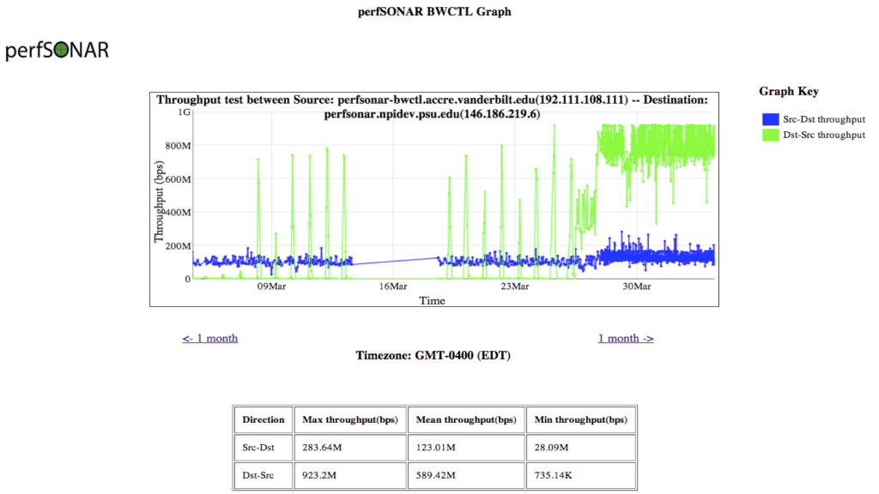

* 74TB of climate data was going to be lost because of UMD servers shutting down unless it was moved back to PSU servers.  Initial transfer attempts indicated an unacceptable total transfer time of 5 months.  perfSONAR performance measurements pinpointed the location of a bottleneck in Maryland.  After informing the Maryland NOC of the situation, they ran their own checks and determined that a fiber patch cable needed cleaned.  The speeds increased 57% to approximately 300Mbps.   While 300Mbps isn't stellar, it decreased the data transfer time to a few days.   With this improvement the data was retrieved before the UMD servers shutdown.  The dotted line in the following graph illustrates the change.  Subsequent work has further increased speeds into the Gbps range (another 10x increase) for future collaboration.

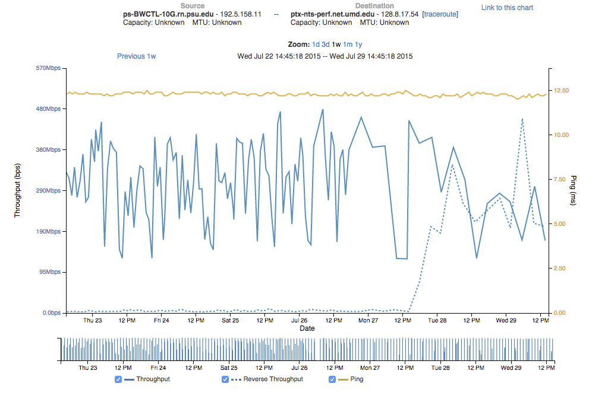

***Proposed Levels of Service***

Together with TNS leadership, the Research Network architects have developed the following service levels. The service levels provide flexible options for accessing the research network.

1. Big Data Access Switch:  *Provides "highest speed" connectivity between distributed research locations and the research network core, including ICS-ACI, with available optional enhanced compliance capabilities.* At the premium level of connectivity to ACI, researchers, departments, and Colleges are equipped with a dedicated switch to extend the Research Network out to their “big data” location.  This solution works for sequencers, instruments, imaging devices, etc.  The 20‐Gbps option provides two 10‐Gbps connections to the Research Network Core and any combination of up to 48 10‐Gbps and 1‐Gbps connections to computing equipment.  This option uses same advanced switching capability as the original Research Network locations.  The Research Network Engagement and Implementation teams will help evaluate specifications for this service and any physical or geographic limitations.   This is the fastest and most flexible solution, but also the most expensive.

* PROPOSED COST\* =  $200 + (10Gbps fiber ports X $20) + (1Gbps copper ports X $1) per month
* EXAMPLE USE CASE:  An existing server room built out to handle large instruments, devices, scopes, sequencers, where 10G fiber is needed at the edge.

1. Data Center CoLo Interconnects:  *Provides "highest speed" connectivity between locations inside the University Data Centers, including ICS-ACI, with available optional enhanced compliance capabilities.* Researchers with equipment in a Data Center (either the Computer Building Data Center or the forth coming Data Center on Tower Road) are encouraged to connect to the Penn State Research Network via the Research Network aggregation switches in those Data Centers at 10‐Gbps.  Doing so provides researchers with direct connections to ICS‐ACI compute clusters and resources located in either of these Data Centers. The connections can be configured to comply with different levels of Federal and/or granting agency requirements.  This option also includes the above mentioned advanced switching capability.

* PROPOSED COST\*  =  10Gbps fiber ports X $25 per month
* Example use case:  A research server on an academic LAN that can be moved into a data center without much disruption to workflow and where ACI services are not available.

1. Distributed Access Switch:  **This connectivity option is currently under trial.***Provides "medium speed" connectivity between distributed research locations and the network core, including ICS-ACI, with available optional enhanced compliance capabilities.* This high‐speed option consists of a 10‐Gbps Ethernet Fabric Switch. This option provides one 10‐Gbps connection from the switch to the Research Network, an additional 10‐Gbps fiber edge port, and either 24 or 48 1‐Gbps copper ethernet connections to individual research workstations or instruments. This option will provide faster access to other points on the Research Network including the ICS‐ACI equipment while reducing network congestion on departmental or College firewalls and LANs.  Existing building wiring can serve 1‐Gbps connections over Category 6/5e copper Ethernet connections and wall jacks. The design of a Federal/granting agency compliant solutions are being evaluated on a switch by switch basis.  The Research Network Engagement and Implementation teams will coordinate these designs to assure seamless integration into the Research Network.

* PROPOSED COST\*  =  $75 per month for a switch with no per-port charge since the last mile is provided by existing building wiring.
* EXAMPLE USE CASE:  Discovered through on-boarding engagements, researchers and college IT have experienced frustratingly slow data transfer speeds to central storage, PASS and ACI, through edge firewalls.  With the proposed distributed connectivity, placing researcher workstations on the Research Network allowed data to move unfettered by poor link speeds and firewall latencies of the local college network.

1. Converged/Compliant Port Connections:  **This connectivity option is currently under development.***Provides "normal speed" connectivity between distributed research locations and the network core, including ICS-ACI, with available optional enhanced compliance capabilities.* At base level of connectivity, individual “research or compliance ports” can be provisioned on an existing ITS managed, converged network switch. Using the capabilities of these switches, a wall jack network connection can be provisioned as a connection on the Research Network. This will be the least expensive solution. It is unclear at audit level whether the virtual port can be made Federal/granting agency compliant. Further investigation is needed. As with the above solution, this will provide a single 1‐Gbps connection to the research network.

* PROPOSED COST\*  =  $2.75 per month per-port charge since the last mile is provided by existing building wiring.
* EXAMPLE USE CASE:  A researcher needs to meet a certain data compliance level on a research workstation to qualify for grant funding.  However, the cost to meet compliance far outweighs that of the grant amount.  A converged per port model would allow a unit, with existing TNS converged switches, the ability to turn a regular data port into a compliance port through Virtual Private LAN Services back to ACI.

1. Data Transfer Performance Tuning:  Even with high-end equipment in place, tuning of the local network, research workstation environment, and even the wide area network may be necessary to optimize data transfer speeds.  Persistent network performance monitoring, with [perfSONAR](http://www.perfsonar.net/" \t "_blank), is in place to maintain and detect transfer speeds to common research areas inside and outside Penn State.  Additional measurement and tuning is currently offered informally on a case-by-case basis.  The service is currently not formally offered, but is being performed informally.

\* Proposed costs represent connection costs charged to researchers.  We recommend core capital equipment purchases and operations be funded centrally.  Central funding support is estimated to be approximately $5,000 per month.

**Appendices to RCCI RN&DC** **Recommendations for the Penn State Research Network**

Penn State University Enterprise Network before the Research Network based on the Science DMZ

PLAN - build - run

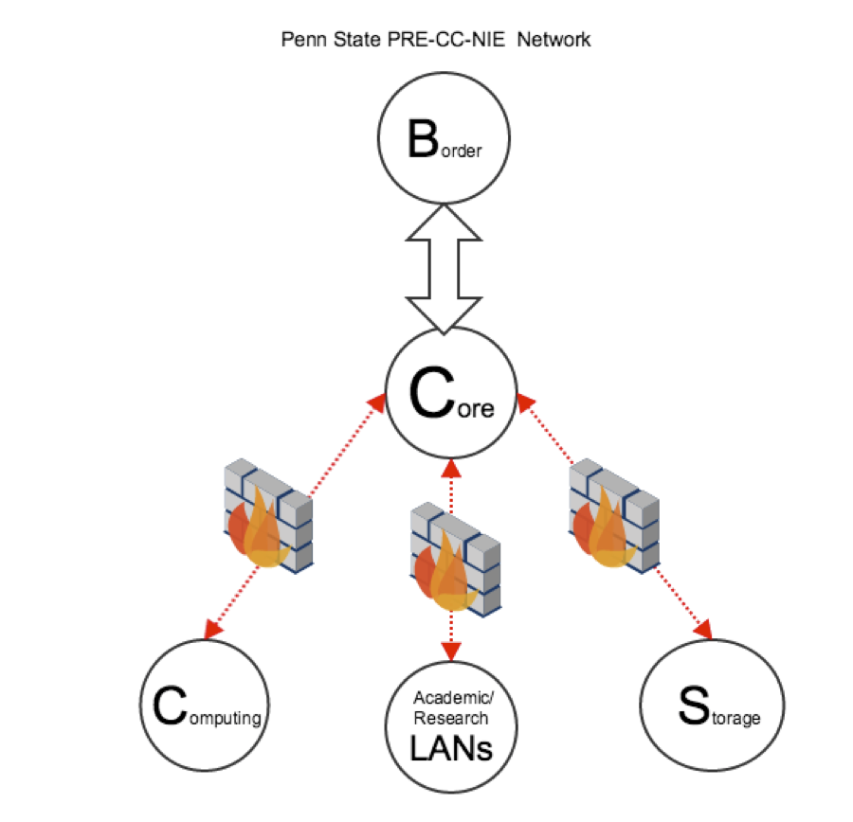

Penn State University Enterprise Network After the Research Network based on the Science DMZ

Research Network 1.0

plan - BUILD - run

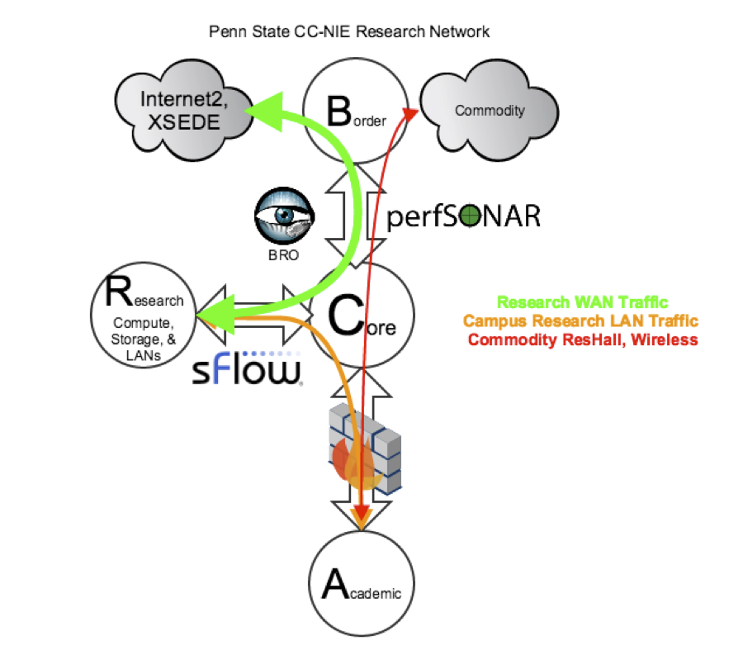

Research Network 2.0

plan - build - RUN

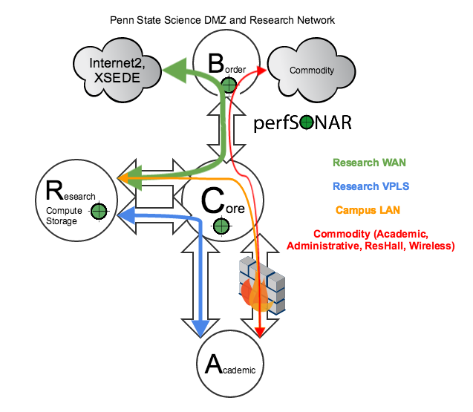

Service Now Workflow and Research On-boarding:

